**Agricultural IoT**

# Introduction

* IoT-enabled technologies are widely used for increasing crop productivity, generating significant revenue, and efficient farming.
* The development of the IoT paradigm helps in precision farming. Agricultural loT systems perform crop health monitoring, water management, crop security, farming vehicle tracking, automatic seeding, and automatic pesticide spraying over the agricultural fields.
* In an IoT- based agricultural system, different sensors necessarily have to be deployed over agricultural fields, and the sensed data from these sensors need to be transmitted to a centralized entity such as a server, cloud, or fog devices.
* Further, these data have to be processed and analyzed to provide various agricultural services. Finally, a user should be able to access these services from handheld devices or computers. Figure 1 depicts a basic architecture of an agricultural IoT.

**Figure 1** Architecture of agricultural I

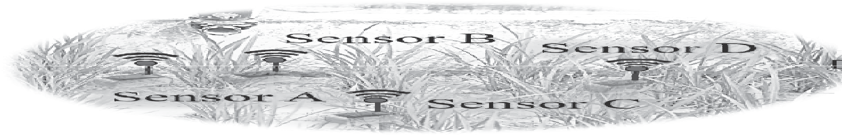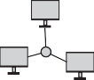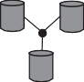

20%

Sensor D

20%

20%

20%

20%

Sensor D

Sensor A

Sensor C

Flow

20%

20%

20%

20%

20%

100

90

80

70

60

100

90

80

70

60

## Components of an agricultural IoT

* The development of an agricultural IoT has helped farmers enhance crop productivity and reduce the overhead of manual operations of the agricultural equipment in the fields.
* Different components such as analytics, drone, cloud computing, sensors, hand-held devices, and wireless connectivity enable agricultural IoT as depicted in Figure 2.

Scnsor

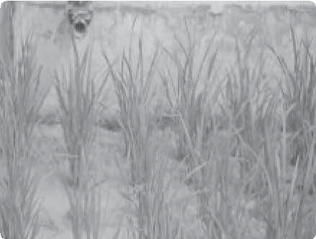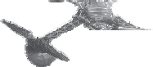

Handheld device

Wireless connectivity

Drone

Cloud computing

Analytics

100%

90%

80%

70%

60%

Camera

Satellite

**Figure 2** Components of agricultural IoT

The different components of an agricultural IoT are discussed as follows:

* **Cloud computing**: Sensors such as the camera, devices to measure soil moisture, soil humidity, and soil pH-level are used for serving different agricultural applications. These sensors produce a huge amount of agricultural data that need to be analyzed.
* **Sensors:** we already explored different types of sensors and their respective requirements in IoT applications. We have seen that the sensors are the major backbone of any IoT application.
* **Cameras:** Imaging is one of the main components of agriculture. Therefore, multispectral, thermal, and RGB cameras are commonly used for scientific agricultural IoT. Cameras are used to estimate thermal stress, nitrogen stress, water stress and crop damage. Video cameras are used for crop security.
* **Satellites:** In modern precision agriculture, satellites are extensively used to extract information from field imagery. The satellite images are used in agricultural applications to monitor different aspects of the crops such as crop health monitoring and dry zone assessing over a large area.
* **Analytics:** Analytics contribute to modern agriculture massively. Farmers can take different agricultural decisions, such as estimating the required amount of fertilizer and water in an agricultural field and estimating the type of crops that need to be cultivated during the upcoming season. Analytics can also be used for estimating the crop demand in market.
* **Wireless connectivity**: Wireless connectivity enables the transmission of the agricultural sensor data from the field to the cloud/server. It also enables farmers to access various application servers over handheld devices.
* **Handheld devices:** e-agriculture has become very popular. One of the fundamental components of e-agriculture is a handheld device such as a smartphone. Farmers can access different agricultural information, such as soil and crop conditions of their fields and market tendency, over their smart phones.
* **Drones:** Currently, the use of drones has become very attractive in different applications such as surveillance, healthcare, product delivery, photography, and agriculture. Drone imaging is an alternative to satellite imaging in agriculture. Drones are also used for crop monitoring, pesticide spraying and irrigation.

An agricultural food chain (agri-chain) represents the different stages that are involved in agricultural activity right from the agricultural fields to the consumers. Figure 3 depicts a typical agricultural food chain with the different operations that are involved in it. Additionally, the figure depicts the applications of different IoT components required for performing these agricultural operations. In the agrichain, we consider farming as the first stage. In farming, various operations, such as seeding, irrigation, fertilizer spreading, and pesticide spraying, are involved. For performing these operations, different IoT components are used.

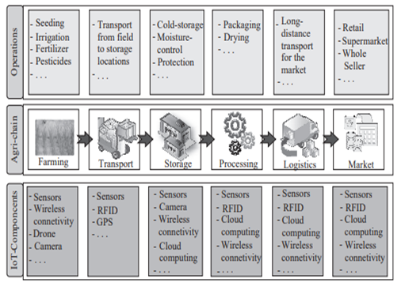

**Figure 3** Use of IoT components in the agricultural chain

* As an example, for monitoring the soil health, soil moisture and temperature sensors are used; drones are used for spraying pesticides; and through wireless connectivity, a report on on-field soil conditions is sent directly to a users’ handheld device or cloud.

* After farming, the next stage in the agri-chain is transport. Transport indicates the transfer of crops from the field to the local storage, and after that, to long-term storage locations. In transport, smart vehicles can automatically load and unload crops.
* The global positioning system (GPS) plays an important role by tracking these smart devices, and radio frequency identification (RFID) is used to collect information regarding the presence of a particular container of a crop at a warehouse.
* Storage is one of the important operations in the agri-chain. It is responsible for storing crops on a long term basis. Typically, cold storage is used for preserving the crops for a long time and providing them with the necessary climatic and storage conditions and protection.
* In the storage, cameras are used to keep a check and protect the harvested crops. The camera feeds are transferred through wireless connectivity to a remote server or a cloud infrastructure.
* Moreover, the amount and type of crops stored in a storage location are tracked and recorded with the help of sensors and cloud computing. For pushing the crops into the market, processing plays a crucial role in an agrichain. Processing includes proper drying and packaging of crops. For drying and packaging, different sensors are used.
* Packaging is the immediate operation prior to pushing the crop into the market. Thus, it is essential to track every package and store all the details related to the crops in the cloud. Logistics enables the transfer of the packed crops to the market with the help of smart vehicles.
* These smart vehicles are equipped with different sensors that help in loading and unloading the packed crop autonomously. Additionally, GPS is used in these smart vehicles for locating the position of the packed crops at any instant and tracking their whereabouts.
* All the logistical information gets logged in the cloud with the help of wireless connectivity. Finally, the packed items reach the market using logistical channels. From the market, these items are accessible to consumers. The details of the sale and purchase of the items are stored in the form of records in the cloud.

**Advantages of IoT in agriculture**

1. **Automatic seeding:**

IoT-based agricultural systems are capable of autonomous seeding and planting over the agricultural fields. These systems significantly reduce manual effort, error probability, and delays in seeding and planting.

1. **Efficient fertilizer and pesticide distribution:**

Agricultural IoT has been used to develop solutions that are capable of applying and controlling the amount of fertilizers and pesticides efficiently. These solutions are based on the analysis of crop health.

1. **Water management:**

* The excess distribution of water in the agricultural fields may affect the growth of crops. On the other hand, the availability of global water resources is finite. The constraint of limited and often scarce usable water resources is an influential driving factor for the judicious and efficient distribution of agricultural water resources.
* Using the various solutions available for agricultural IoT, water can be distributed efficiently, all the while, increasing field productivity and yields.
* The IoT-enabled agricultural systems are capable of monitoring the water level and moisture in the soil, and accordingly, distribute the water to the agricultural fields.

1. **Real-time and remote monitoring:**

Unlike traditional agriculture, in IoT-based farming, a stakeholder can remotely monitor different agricultural parameters, such as crop and soil conditions, plant health, and weather conditions. Moreover, using a smart handheld device (e.g., cellphone), a farmer can actuate on-field farming machinery such as a water pump, valves, and other pieces of machinery.

1. **Easy yield estimation:**

Agricultural IoT solutions can be used to record and aggregate data, which may be spatially or temporally diverse, over long periods. These records can be used to come up with various estimates related to farming and farm management. The most prominent among these estimates is crop yield, which is done based on established crop models and historical trends.

1. **Production overview:**

* The detailed analysis of crop production, market rates, and market demand are essential factors for a farmer to estimate optimized crop yields and decide upon the essential steps for future cropping practices.
* Unlike traditional practices, IoT-based agriculture acts as a force multiplier for farmers by enabling them to have a stronger hold on their farming as well as crop management practices, and that too mostly autonomously. Agricultural IoT provides a detailed product overview on the farmers’ handheld devices.

# Case Studies

## In-situ assessment of leaf area index using IoT-based agricultural system

* In this case study, we focus on an IoT-based agricultural system developed by Bauer et al. [1]. The authors focus on the in-situ assessment of the leaf area index (LAI), which is considered as an essential parameter for the growth of most crops.
* LAI is a dimensionless quantity which indicates the total leaf area per unit ground area. For determining the canopy (the portion of the plant, which is above the ground) light, LAI plays an essential role.

### Architecture

* The authors integrated the hardware and software components of their implementation in order to develop the IoT-based agricultural system for LAI assessment.
* One of the important components in this system is the wireless sensor network (WSN), which is used as the LAI assessment unit.
* The authors used two types of sensors:

1. Ground-level sensor (G)
2. Reference sensor (R).

* These sensors are used to measure photosynthetically active radiation (PAR). The distance between the two types of sensors must be optimal so that these are not located very far from one another. In this system, the above-ground sensor (R) acts as a cluster head while the other sensor nodes (Gs) are located below the canopy.
* These Gs and R connected and form a star topology. A solar panel is used to charge the cluster head. The system is based on IoT architecture. Therefore, a cluster head is attached to a central base station, which acts as a gateway. Further, this gateway connects to an IoT infrastructure. The architecture of the system is depicted in Figure 4.

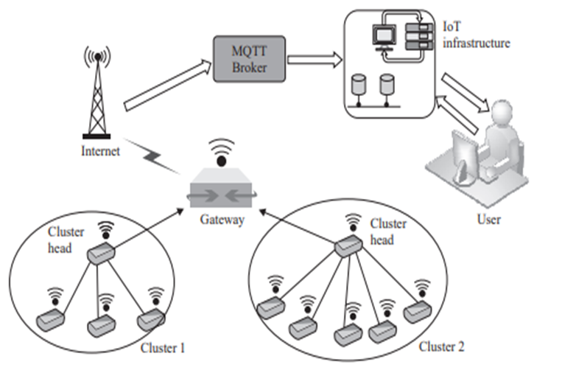

**Figure 4** System architecture

### Hardware

### Hardware For sensing and transmitting the data from the deployment fields to a centralized unit, such as a server and a cloud, different hardware components are used in the system. The commercial off-the-shelf (COTS) TelosB platform is used in the system.

### The TelosB motes are equipped with three types of sensors:

### Temperature, humidity, and light sensors.

### With the help of an optical filter and diffuser accessory on the light sensors, the PAR is calculated to estimate the LAI. The system is based on the cluster concept. A Raspberry-Pi is used as a cluster head, which connects with four ground sensor motes.

### The Raspberry-Pi is a tiny single board, which works as a computer and is used to perform different operations in IoT. Humidity and wet plants intermittently cause attenuation to the system, which is minimized with the help of forward error coding (FEC) technique.

### The real deployment of the LAI assessment system involves various environmental and wild-life challenges. Therefore, for reliable data delivery, the authors take the redundant approach of using both wired and wireless connectivity.

### In the first deployment generation, USB power supply is used to power-up the sensors motes. Additionally, the USB is used for configuring the sensor board and accessing the failure as per requirement. In this setup, a mechanical timer is used to switch off the sensor nodes during the night.

### In the second deployment generation, the cluster is formed with wireless connectivity. The ground sensor motes consist of external antennas, which help to communicate with the cluster head. A Raspberry-Pi with long-term evolution (LTE) is used as a gateway in this system.

### Communication

### The LAI system consists of multiple components, such as WSN, IoT gateway, and IoT based network.

### All of these components are connected through wired or wireless links. The public land mobile network (PLMN) is used to establish connectivity between external IoT networks and the gateway.

### The data are analyzed and visualized with the help of a Farm management information system (FMIS), which resides in the IoT-based infrastructure. Further, a prevalent data transport protocol: MQTT, is used in the system.

### Software

* Software is an essential part of the system by which different operations of the system are executed. In order to operate the TelosB motes, TinyOS, an open-source, low-power operating system, is used.
* This OS is widely used for different WSN applications. Typically, in this system, the data acquired from the sensor node is stored with a timestamp and sequence number (SN). For wired deployments, the sampling rate used is 30 samples/hour.
* IoT Architecture The MQTT broker runs in the Internet server of the system. This broker is responsible for receiving the data from the WSN.
* In the system, the graphical user interface (GUI) is built using an Apache server.

## Smart irrigation management system

* In precision agriculture, the regular monitoring of different agricultural parameters, such as water level, soil moisture, fertilizers, and soil temperature are essential.
* This case study highlights a prototype of an irrigation management system [2], developed at the Indian Institute of Technology Kharagpur, funded by the Government of India. The primary objective of this system is to provide a Web-based platform to the farmer for managing the water supply of an irrigated agricultural field.

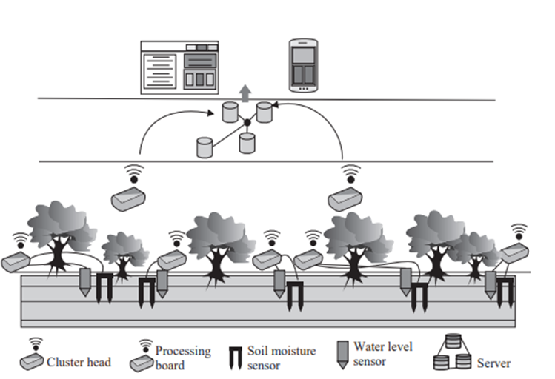

**Figure 5** Architecture: Smart irrigation management system



1. **Sensing and Actuating layer:**

* This layer deals with different physical devices, such as sensor nodes, actuators, and communication modules.
* In the system, a specially designated sensor node works as a cluster head to collect data from other sensor nodes, which are deployed on the field for sensing the value of soil moisture and water level.
* A cluster head is equipped with two communication module: ZigBee and General Packet Radio Service (GPRS).
* The communication between the deployed sensor nodes and the cluster head takes place with the help of ZigBee.
* Cluster heads use GPRS to transmit data to the remote server. An electrically erasable programmable read-only memory (EEPROM), integrated with the cluster head, stores a predefined threshold value of water levels and soil moisture.

1. **Processing and Service layer**:

* This layer acts as an intermediate layer between the sensing and actuating layer and the application layer.
* The sensed and processd data is stored in the server for future use. Moreover, these data are accessible at any time from any remote location by authorized users.
* Depending on the sensed values from the deployed sensor nodes, the pump actuates to irrigate the field.

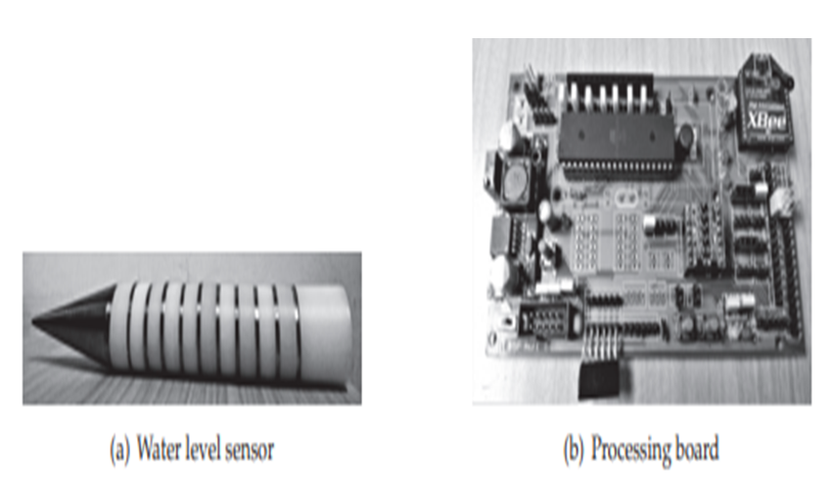

**Figure 6** Water level sensor and processing board

1. **Application layer:**

* The farmer can access the status of the pump, whether it is in switch on/off, and the value of different soil parameters from his/her cell phone.
* This information is accessible with the help of the integrated GSM facility of the farmers’ cell phone. Additionally, an LED array indicator and LCD system is installed in the farmers’ house.

**Deployment**:

* The system has been deployed and experimented in two agricultural fields:

(i) An agricultural field at the Indian Institute of Technology Kharagpur (IIT Kharagpur), India, and (ii) Benapur, a village near IIT Kharagpur, India.

* Both the agricultural fields were divided into 10 equal sub-fields of 3 × 3m2.
* In order to examine the performance, the system was deployed at over 4 sub-fields. Each of these sub-fields consists of a solenoid valve, a water level sensor, and a soil moisture sensor, along with a processing board.
* The remaining six sub-fields were irrigated through a manual conventional irrigation process. The comparison analysis between these six and four fields summarily reports that the designed system’s performance is superior to the conventional manual process of irrigation.

# Exercises

1. List the type of sensors which can be used for agricultural IoT.
2. Explain two use cases where drones can be used for agricultural IoT.
3. Design a scenario where we can use fog computing in agriculture.
4. How can agricultural IoT help in the efficient distribution of water in agricultural fields?
5. What are the roles of the various IoT components in an agri-chain?
6. What are the advantages of agricultural IoT?
7. List a few communication modules used for agricultural IoT?
8. Design a case study to develop an IoT-based agricultural planter. In the case study, you should include the requirement analysis of different components and justify their usability in the planter.
9. What is the importance of satellites in agricultural IoT?